** 2025 Message from the CEO:**

***The Year to Thrive***

As we embark on 2025, I am excited to announce that this is the year for AGC New Mexico to **THRIVE**. Building on the momentum we've gained, this year will be about expanding our achievements, deepening our partnerships, and continuing to be a force for positive growth in the construction industry. As Brent mentions in his President's message, thriving means taking the groundwork we've laid and advancing our industry through innovation, collaboration, and strategic action.

Much like how uncertainty in history created opportunities—consider how World War I restructured the workforce to include women—AGC is using the challenges of today to create opportunities for tomorrow. Our leadership embraces that same mindset as we set strategic goals to help the construction industry thrive. Over the next three years, you’ll see AGC NM thrive by expanding the labor pool through initiatives that address underserved populations, which will help fill the workforce gap. We will continue to strengthen the resources available to retain a thriving workforce by focusing on mental health, suicide prevention, and comprehensive training programs.

**Thriving Workforce Solutions**  
Did you know that AGC has the state's only open-shop concrete and glazing apprenticeship program? We are proud of how our apprenticeship and pre-apprenticeship programs are growing, ensuring that the next generation of contractors is well-equipped to succeed. AGC has a proven track record of leading through uncertain times and emerging even stronger.

**Innovating Through Challenges**  
As we look forward, we will continue working with public officials to help them understand the drivers of cost and reduce the regulatory burdens contributing to cost escalation. AGC is committed to connecting our core values to meaningful action. We are RELEVANT, and that relevancy will continue to pave the way for long-term success in New Mexico's construction industry.

**Your Competitive Advantage**  
My message to AGC members is simple: We welcome uncertainty and use it as a springboard for growth. AGC is your competitive advantage. Our professional development opportunities are unmatched—whether it’s through the Certified Safety Technician training, the Supervisory Training Program, or our new **Empower to Thrive** course specifically designed for women in the industry, we are here to help you succeed. AGC’s innovation and problem-solving capacity are a direct reflection of the great leaders and professionals who drive our initiatives forward.

I commend our AGC leadership and staff for their dedication to staying both highly focused and highly flexible in times of uncertainty. As we continue to grow, innovate, and thrive together, I am confident that 2025 will be a year of lasting impact for our members and the entire construction industry.

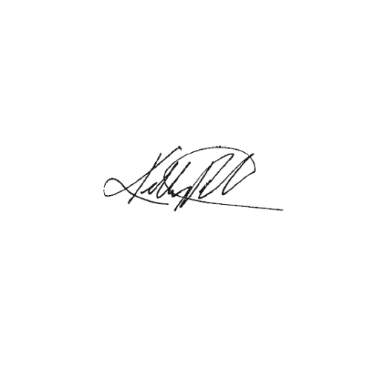

***Kelly Roepke-Orth***, CEO