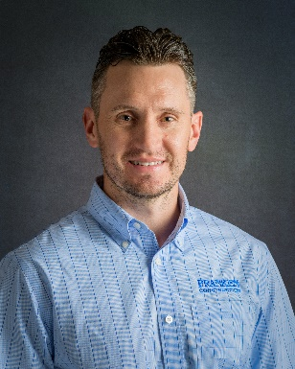 **AGC NM PRESIDENT'S MESSAGE - 2025:**

***"Building Futures, Strengthening Foundations"***

As we move into 2025, I am honored to serve as President of AGC New Mexico and represent an industry that continues to find opportunities amid uncertainty. This year, our focus is on building exciting new partnerships that will collectively advance the construction industry in New Mexico. We’ve embarked on an ambitious 3-year strategic plan, designed to address the evolving needs of our industry while reinforcing the core values that have made AGC NM a trusted voice for contractors across the state.

A major highlight this year is the exciting progress within the **AGC New Mexico Building Education Foundation (NMBEF)**. I’m proud to announce that NMBEF has established its second endowment under the Civil Engineering and Construction Management program. In addition, we have launched new scholarship applications for both graduate and undergraduate students committed to careers in construction, and we are especially proud to introduce a new scholarship program dedicated to supporting women in the construction industry.

In line with our commitment to growing member engagement, AGC has also created a **new Membership Services position**. In the coming weeks, you can expect to receive a call from our team to set up a meeting with your firm. This meeting will help us better understand how AGC can add value and deliver on your firm’s specific needs. Additionally, we’ll be promoting your company through a social media post, showcasing your brand to the owners and public officials we work closely with. This is one of the many ways we continue to provide exposure and strengthen the voice of our members in the industry.

A key part of our mission in 2025 is delivering more value through increased engagement and collaboration. While we remain committed to selling out our premier industry events, we are also introducing innovative new opportunities for effective networking. One of our main areas of focus is growing our **Construction Leadership Council (CLC)**, empowering the next generation of leaders and ensuring they are equipped to shape the future of construction in New Mexico.

Career exploration remains a priority for us, highlighted by the success of our annual **Heavy Equipment Rodeo**, which provides students with hands-on exposure to the possibilities within our industry. These initiatives are not just about building skills—they’re about building futures.

My year as president is about engagement. Whether through our events, committees, or advocacy efforts, I am focused on ensuring that AGC NM continues to provide the value of a unified voice for our members. As your professional industry organization, we are here to support you, your businesses, and the communities we help build.

I look forward to working alongside each of you as we navigate this exciting year together and deliver on our shared vision for a thriving construction industry in New Mexico.

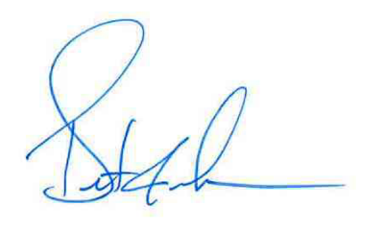

***Brent Franken***, 2025 AGC NM President